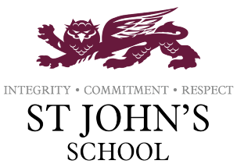
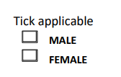
SCHOOL UNIFORM
Order Form 2024/25

Student’s Name: _____________________________ Year Group: _________

Must have items – Trousers of the same style and colour can be purchased elsewhere.

Uniform Item | Cost | Age / Size | No. Required | Total cost
Polo shirt | €10
Skirt | €15
Shorts | €15
Boys Trousers | €10
Girls Trousers | €10
Jumper | €15
Cardigan | €15

Uniform Item | Cost | Age / Size | No. Required | Total cost
Blazer  (limited stock and sizes) | €25
Hoodie | €20

PE Kit Item | Cost | Age / Size | No. Required | Total Cost
House Shirt / Apollo | €15
House Shirt / Poseidon | €15
Black Plain Shorts | €5
All students also require a pair of trainers (Not sold in school)

Total cost of all uniform ordered:
Final total:
Date:

Cash payment only

If you wish to look at our uniform please visit our website under the following link:
https://www.stjohnsschoolcyprus.com/information/uniform

